|  |  |  |  |  |  |
| --- | --- | --- | --- | --- | --- |
| Date | 6-Dec-22 | | | Tester Name | Richard Belanger |
| Environment | Penfax - Test | | | Login used | TEST2 |
| Operating System | Windows | Version: | Update: | | |
| Software Used | Edge | Version: | Update: | | |
| Not Applicable | Version: | Update: | | |
| Release version | 22.4.1 | | | | |
| Title | M12.06 Single General member over the age 65 | | | | |
| Test Type | Regression | | | | |
| Test Scenario | Death of Active member over age 65 | | | | |
|  |  | | | | |
| Expected Results | The member will be terminated and beneficiary will be paid | | | | |
| Pass/Fail | Pass | | | JIRA# | N/A |

Describe your steps with screenshots:

Member terminated due to death

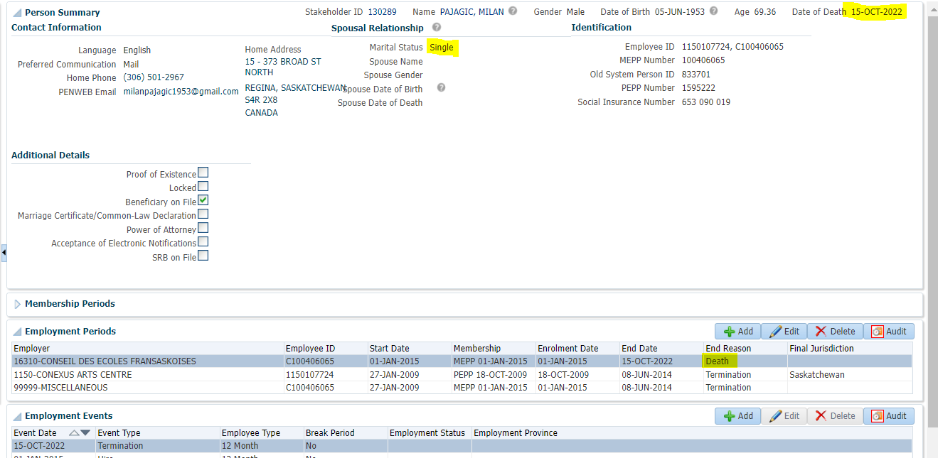

To Benefit Calculation>Calculate

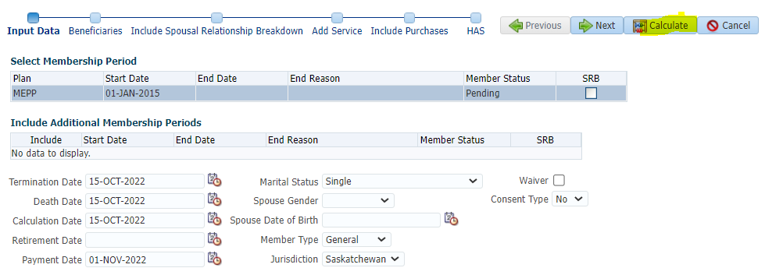

Processed

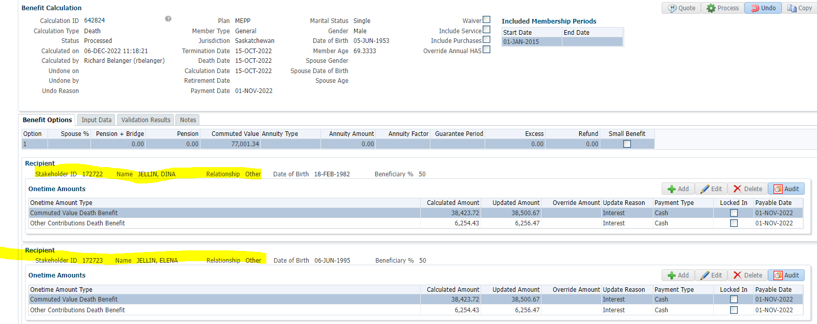

To Benefit Selection>Next

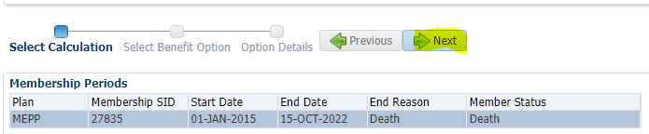

Choose Option add payment date>Next

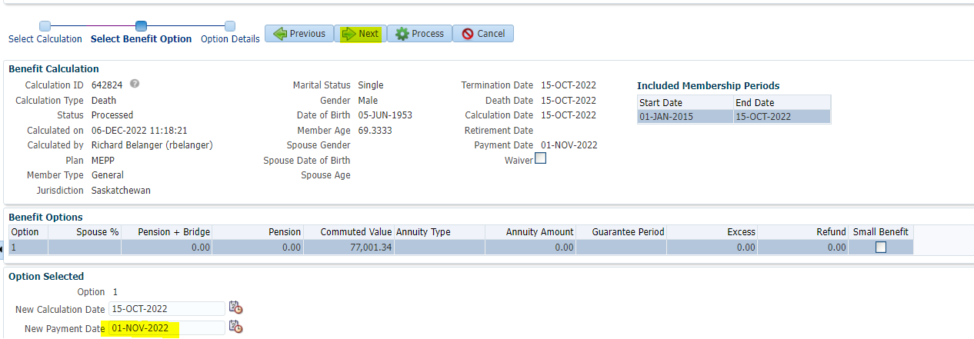

Add Payment Instructions>Process SID-172722 will receive RRSP/Cash; SID- 172723 will receive RRSP/Cash

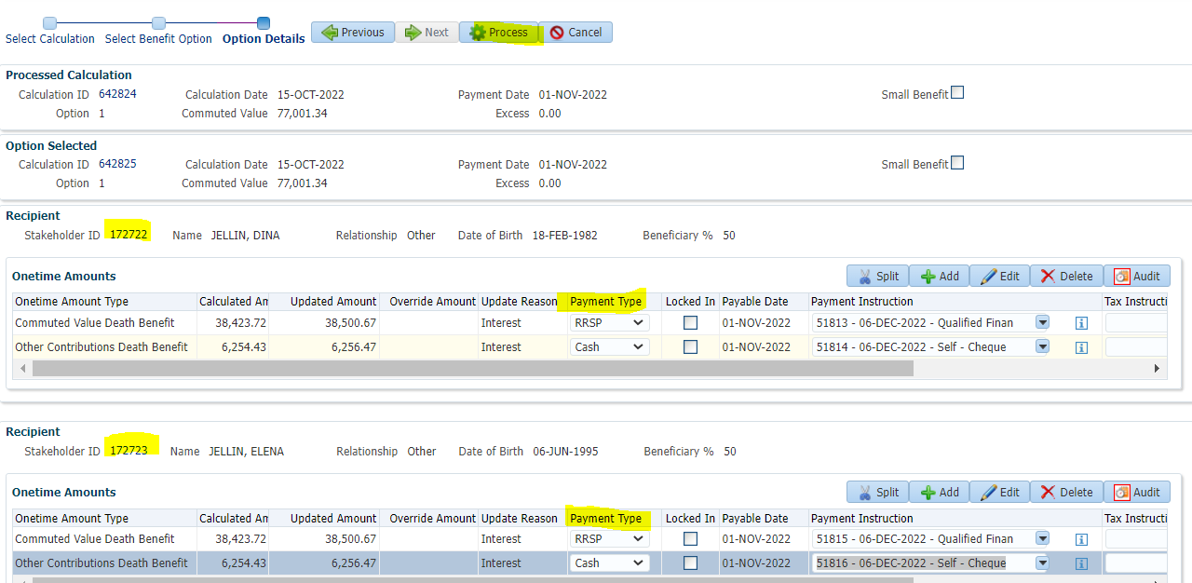

Processed

To Beneficiary>Benefit Recipient SID-172722 will receive RRSP/Cash

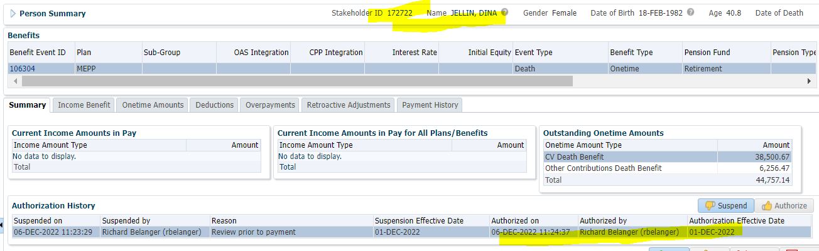

To Beneficiary>Benefit Recipient SID- 172723 will receive RRSP/Cash

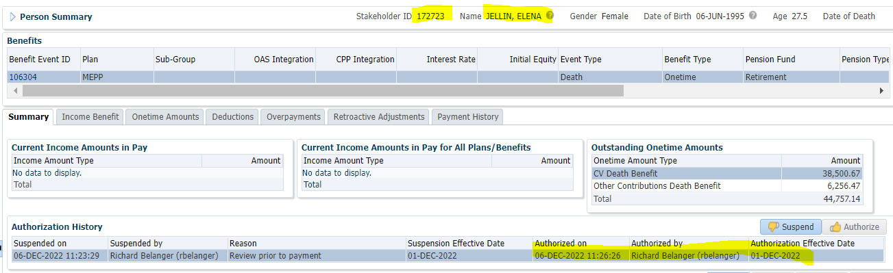

Payment Batch to run to see payments made

Tax Rates

0.00-4,999.99 = 10%

5,000.00- 14,999.99 = 20%

15,000.00+ = 30%

SID-172722 will receive RRSP/Cash-

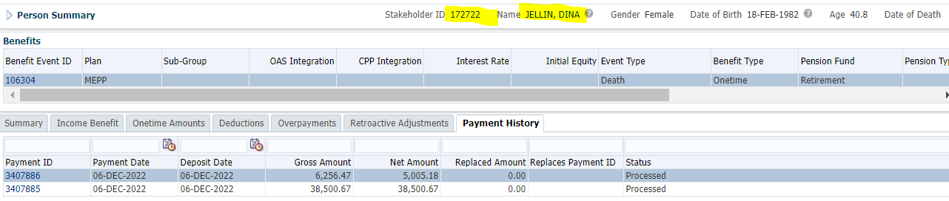

RRSP amount not Taxed

Cash amount; 6256.47 x 20% = 1,251.29; 6256.47 – 1251.29 = **$5,005.18**

SID- 172723 will receive RRSP/Cash

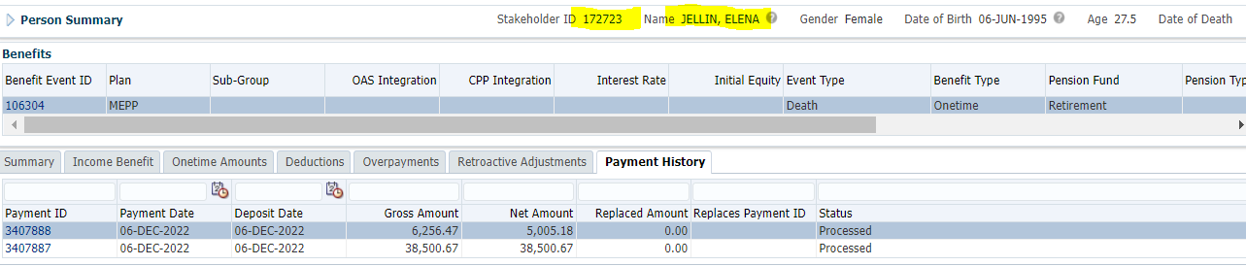

RRSP amount not Taxed

Cash amount; 6256.47 x 20% = 1,251.29; 6256.47 – 1251.29 = **$5,005.18**